SNS-Simple Notification Service

Objectives-
- To design and implement an Amazon SNS Standard Topic for reliable email-based notification delivery.
- To configure and manage multiple email subscriptions under a single SNS topic for group communication.
- To validate and confirm subscriptions through the email verification mechanism provided by Amazon Web Services SNS.
- To demonstrate the capability of publishing messages to an SNS topic, ensuring simultaneous delivery to all confirmed subscribers.
- To understand the working of a publish-subscribe (pub-sub) messaging system using Amazon SNS.
- To evaluate the efficiency of SNS in real-time notification and alert systems.
Step 1- Select Topics in AWS SNS Service home page.
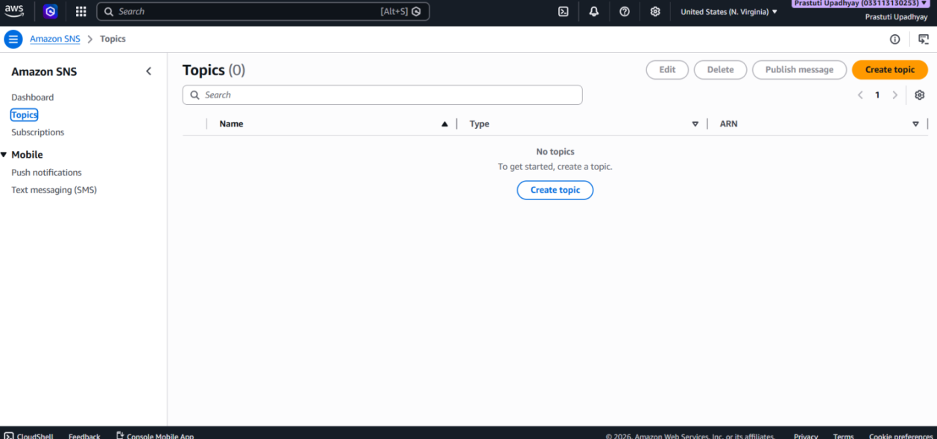
Step 2- Click Create Topics in Topics :
• Choose the Standard topic type to enable high-throughput and scalable message delivery.
• Configure the topic with the following details:
- Name: Testing-email.
- Display Name: Notification.
- Click on Create Topic to proceed.
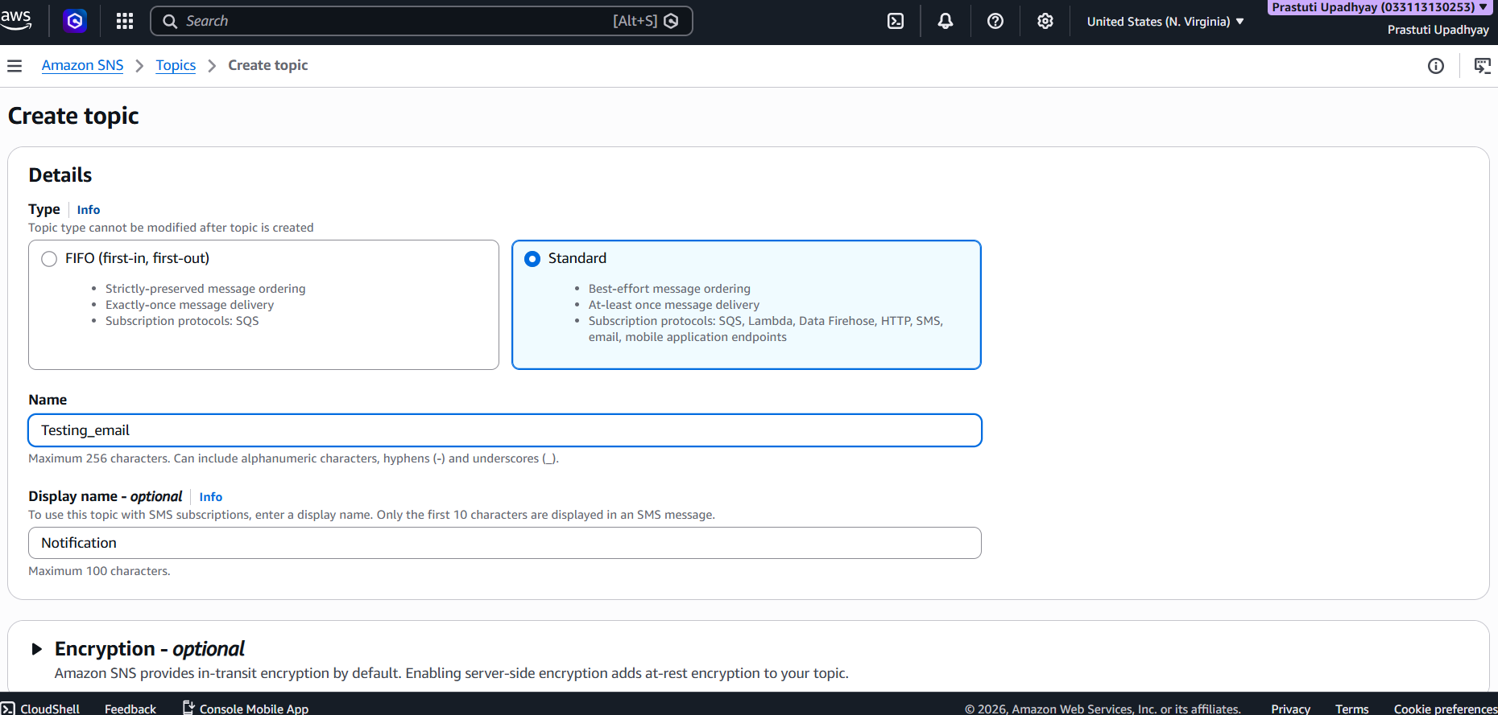
Step 3- Topic Created.
- After clicking Create topic, you will be automatically redirected to the topic details page in Amazon SNS.
- On this page, you can view important details such as the Topic ARN, configuration settings,and available actions for managing the topic.
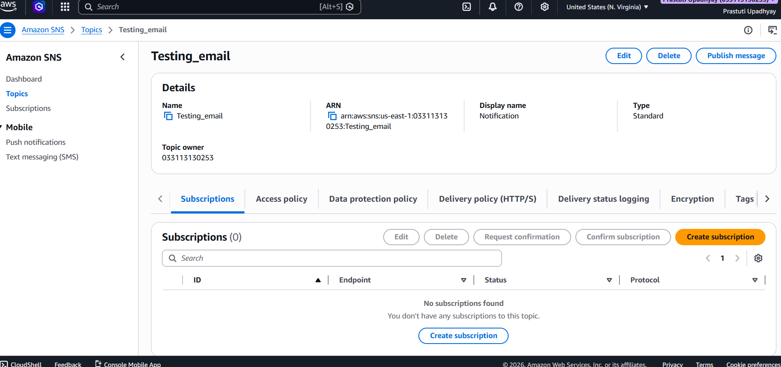

Step 4-

Create the First Email Subscription :
- On the topic details page in Amazon SNS, click the Create subscription button.
- In the Create subscription form, configure the following details:
  - Protocol: Email.
  - Endpoint: Enter the email address of the first subscriber.
- Click on Create subscription to complete the process.
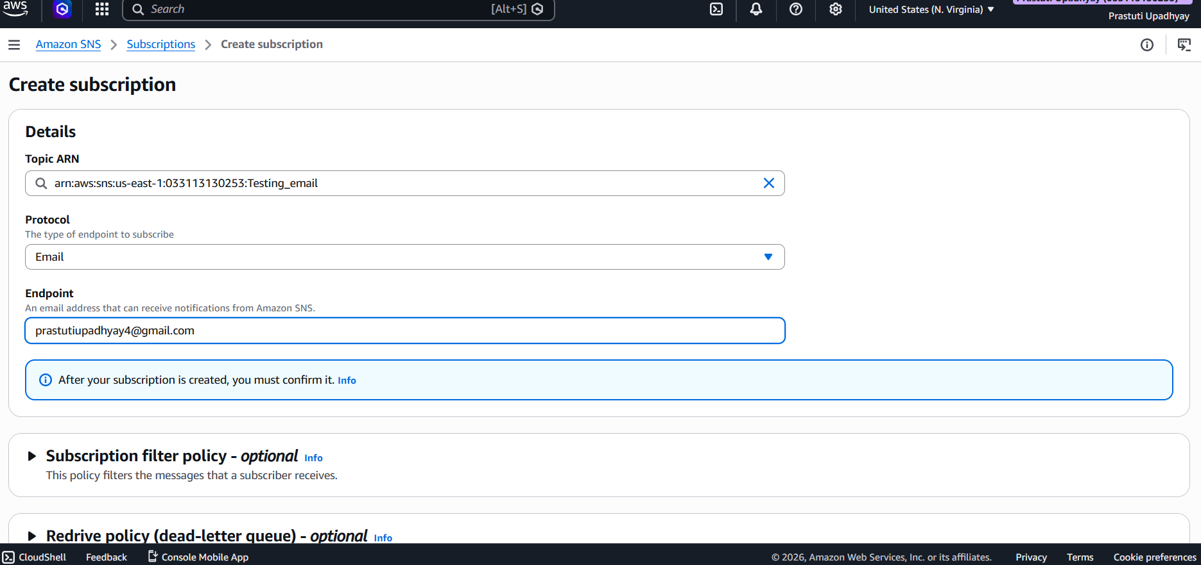
Step 4- First Subscription created. When in status it is Confirmed.
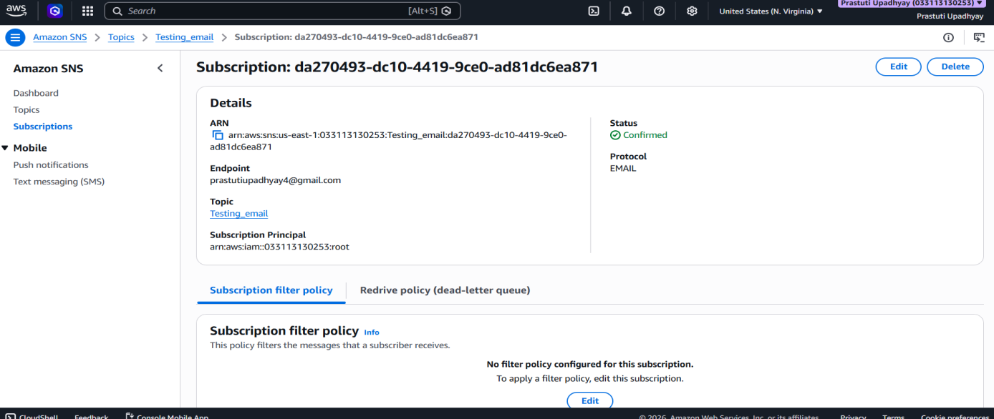

Step 5-

Create the Second Email Subscription :
- On the topic details page in Amazon SNS, click the Create subscription button.
- In the Create subscription form, configure the following details:
  - Protocol: Email.
  - Endpoint: Enter the email address of the second subscriber.
- Click on Create subscription to complete the process.
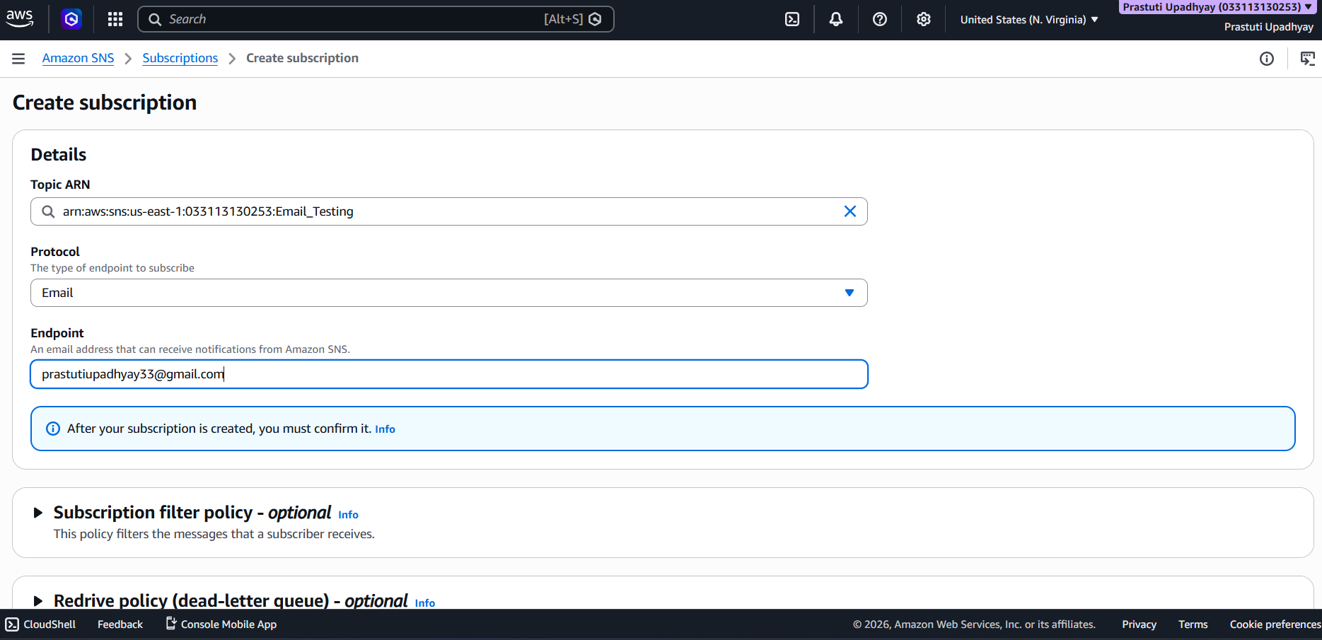
Step 6- Second Subscription created. When in status it is Confirmed.
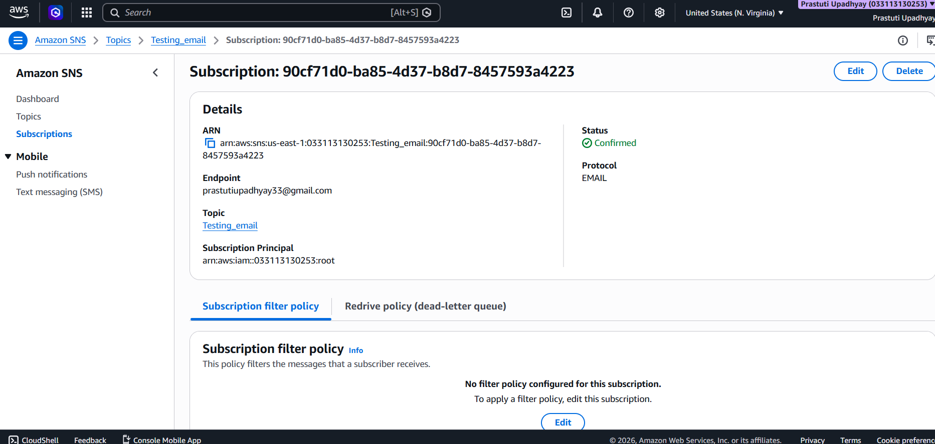
Step 7- Publish a Message to the SNS Topic:
Go back to the Testing-email topic and select the Publish message option. In the message configuration page, enter the following:
- Subject: Project Notification – AWS SNS Email Test.
- Message: This message is sent to verify that the SNS topic and email subscription are working correctly as part of the project setup.
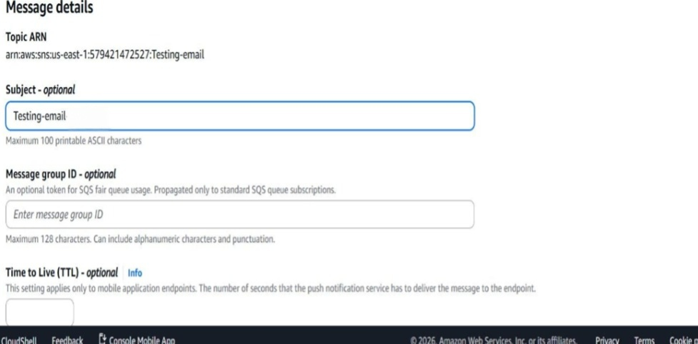
Step 8- Configure the Message Body :
Scroll down to the Message body section and set up the following:
- Message structure: Select Identical payload for all delivery protocols.
- Message content: Enter Hello AWS – This is a test message from the SNS project.
After completing the configuration, click Publish message to deliver the message to all confirmed subscribers.
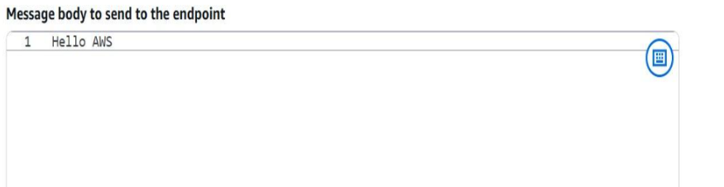

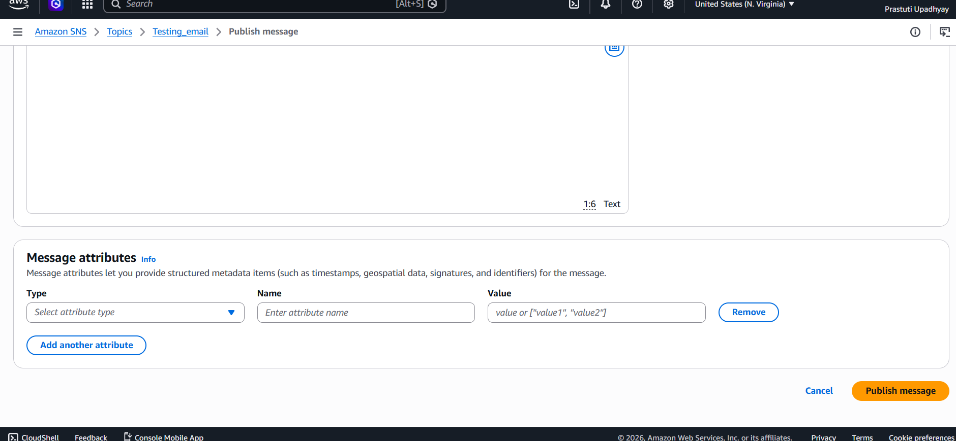
Step 9- Delivered the notification to all subscribed email endpoints. Then for the confirmation check the status if it is confirmed then the message is delivered.
